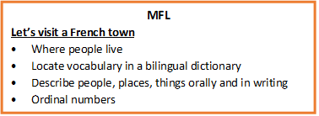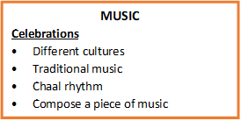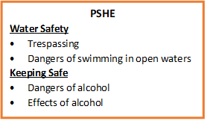

**SCIENCE**

**Human Body**

* The heart
* Blood vessels
* Blood pressure and heart rate
* Heart rate investigation

**DT**

**Water Walls**

* Research and investigate
* Archimedes screw and a pulley
* Design criteria

**COMPUTING**

**Coding**

* Design and make a game
* Flowcharts and control simulations
* User input
* Using text-based adventures

**FOREST SCHOOL**

* Fire lighting
* Outdoor cooking

**HISTORY**

**World War One**

* Causes of WW1
* On land, at sea and in the air
* Life on the Western Front
* The Home Front
* Consequences of the war

**PE**

* OAA
* Netball

**ART**

**Italian Renaissance**

* Leonardo da Vinci
* Painting techniques
* Michelangelo
* Realistic painting
* Linear perspective

**GEOGRAPHY**

**Spatial Sense**

* Latitude and longitude
* The Arctic and Antarctic circles
* Time zones
* Map projection
* Maps of the world

**RE**

**What will make our community a more respectful place?**

* Local religions
* Religious traditions
* Community cohesion
* Respectful attitudes

**MATHS**

**Place value**

* Numbers up to 10 million
* Compare and order numbers
* Rounding numbers to 10 million

**Addition and Subtraction**

* Use formal methods
* Problem solving

**Multiplication and Division**

* Multiply 4 digits by 2 digits
* Short & long division
* Problem solving
* Order of operations

YEAR SIX: AUTUMN TERM 1

**ENGLISH – Stay Where You Are and then Leave**

* Diary entries
* Letter writing
* Persuasive writing
* Poetry and performance

**Reading Comprehension - Cosmic**