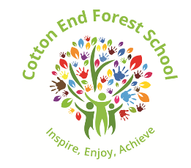

**Highlights from this week**

We have been busy learning about wild and endangered animals and their habitats.

We have been looking at books and sharing our knowledge about them with our friends.

We certainly enjoyed learning about camels and I was very impressed with the drawings the children have made of them this week!

We focused on hearing the initial sound “a” in words like, ant, apple and arrow.

<https://www.bbc.co.uk/cbeebies/watch/cbeebies-phonics-playlist#playlist>

Listen carefully to the pure phonic sound of a

Cherry Class Preschool Newsletter Friday 12 May 2023

**Next week in Cherry Class**

We will be learning about animals from the Arctic and the Antarctic.

We will be melting ice

Drawing our favourite polar creature

Making polar bear faces.

and lots more!

We will continue to look at repeating patterns. They are very important to our mathematical development. Can you make repeating patterns at home?

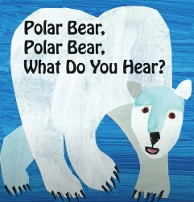

**Things to know**

Sun! The temperatures have definitely got warmer recently! Please apply sun screen to your child **before** they come into any school session. If your child attends **all day** please bring a bottle of sun screen to be kept at school. This bottle **must** to be clearly marked with your child’s name. Children will reapply the lotion with adult guidance.

**Please check the ingredients – as we will not be able to accept any cream that contains almonds.**

<https://www.youtube.com/watch?v=WaTZaOolniU>

We share stories many times through the day. We will be reading this story! Have a look at this video clip!