What to do today
IMPORTANT! Parent or Carer – Read this page with your child and check that you are happy with what they have to do and with any weblinks or use of the Internet required.

1. Story time
Go back to https://www.youtube.com/watch?v=RbyUrb0X5iU&t=94s.
Watch The Way Home all the way through to the end.
- How accurate were your predictions or your recall of events for the remaining part of the story?

2. Commands and explanations
Read the information on Command and Exclamation Sentences.
- Answer Questions about types of sentence.
- Read the Way Home Sentences.
- Put a C, Q, E or S next to each one depending on whether it is a command, question, exclamation or statement.
- Add the correct punctuation to each sentence.

3. Comparing stories by the same author
Think about The Way Home and Lost and Found.
Look at the headings on Two Stories by Oliver Jeffers.
- Write your responses in the spaces provided.

Now try this Fun-Time Extra
- The boy settles down to watch his favourite TV programme while the Martian is stuck on the Moon. You can see it is a wildlife show.
- What’s your favourite programme? Draw a picture of it and explain why you like it on My Favourite TV Programme.

Command and Exclamation Sentences

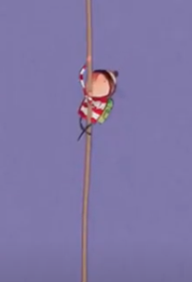

A sentence is a command when it is bossy and gives an order or an instruction.
Commands begin with bossy verbs.

Fix my aeroplane.
Climb down the ladder!
Do not watch the TV while I am gone.

Commands begin with capital letters.
They often end with full stops.
They can end with exclamation marks if they are very forceful and are being given with extra emphasis.

Exclamation sentences begin in two very particular ways. They start with the words How... or What... and are said in a short, sharp, emphatic way.

How extraordinary to see a Martian!
What a relief to get back to Earth!
How lovely to be home.

Exclamations begin with capital letters.
They end with exclamation marks if they are very forceful or full stops if they are less so.
Questions about types of sentence
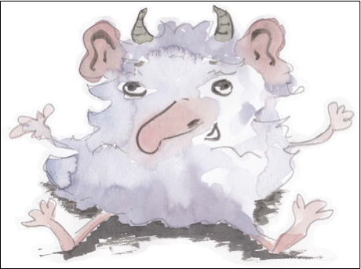
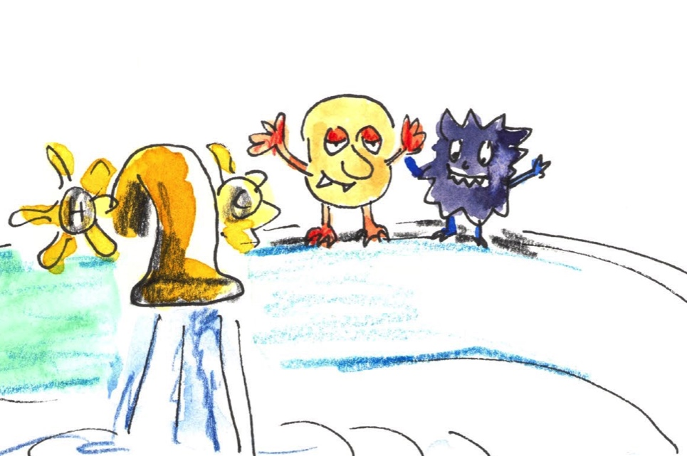

Write ‘command’ or ‘statement’ or ‘exclamation’ beside each sentence below.
Then add the correct end-of-sentence punctuation.

- Turn off the tap
- The alien looks pretty cute
- How annoying
- What a shock
- Go away, you aliens
- Aliens love water and taps
- Stop playing in the bathroom

Write four bossy verbs which could be used to start a command.

What type of letter must be used to start a command sentence?

What punctuation mark is used at the end of a command sentence?

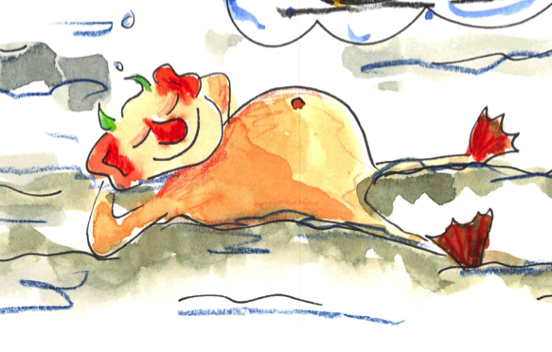

Way home Sentences

Where have you come from
His torch went out
They thought of ways to fix their machines
What a rubbish plane I have
How will we get home
Grab this rope
Go and fetch the bits we need
What do we need to fix our machines
How scary the moons feels in the dark
Where is he
He should be back by now
Go home now
How wonderful that the machines now work
Two stories by Oliver Jeffers

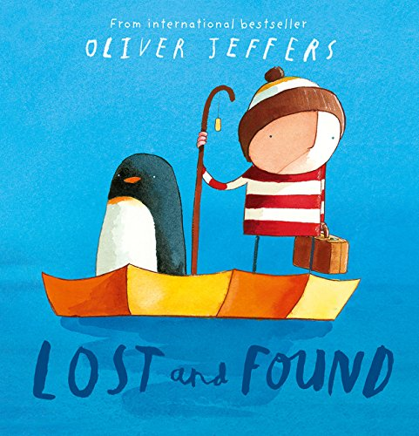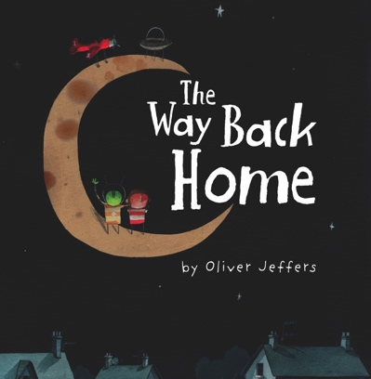

Write about all the things that the books have in common.
Think about the characters and what they do in the books, but also about the themes and the ideas in the stories.
____________________________________________________________________________________________________________________________________________________________________________________________________________________________________________________________________________________________________________________________________________________________________________________

Which is your favourite of the two books?
______________________________________________________________

Explain why you like it the best.
________________________________________________________________________________________________________________________________________________________________________________________________________________________________________________________________________________________________________________________________________________________________________________________________________________________________________________________________________________________________________________

My Favourite TV Programme

Answers Questions about types of sentence
Children may have used exclamation marks to end the command sentences if they feel they should be read forcefully or given extra emphasis.
- Turn off the tap. Command
- The alien looks pretty cute. Statement
- How annoying! Exclamation
- What a shock! Exclamation
- Go away, you aliens. Command
- Aliens love water and taps. Statement
- Stop playing in the bathroom. Command

Write four bossy verbs which could be used to start a command.
Answers will vary, e.g. fix, climb, mix, stop, put

What type of letter must be used to start a command sentence?
Capital letter
What punctuation mark is used at the end of a command sentence? Full stops (or sometimes exclamation marks).
Way home Sentences

Where have you come from? Question
His torch went out. Statement
They thought of ways to fix their machines. Statement
What a rubbish plane I have! Exclamation
How will we get home? Question
Grab this rope. Command
Go and fetch the bits we need. Command
What do we need to fix our machines? Question
How scary the moon feels in the dark! Exclamation
Where is he? Question
He should be back by now. Statement
Go home now. Command
How wonderful that the machines now work! Exclamation

