What to do today
IMPORTANT! Parent or Carer – Read this page with your child and check that you are happy with what they have to do and with any weblinks or use of the Internet required.

1. Story time
Go to https://www.youtube.com/watch?v=g-N-m0N0vtM&t=5s.
Watch the Lost and Found film trailer.
- Does the trailer make you want to see the film? Why/not?
- Why does the trailer not show the ending of the story at all?

2. Planning a story
Read the Story Instructions.
Think about how the penguin might have stopped the boy from taking him home to the South Pole.
- Use your Story Planner to capture all your great story ideas.

3. Writing a story
Use pages of story paper to write out your story.
- Add some illustrations to the borders of your pages.

Now try this Fun-Time Extra
“Like any friendship, theirs is a remarkable story indeed,” says the narrator in the film clip about the boy and the penguin.
- On A Remarkable Person, draw and write about a friend or someone else really special in your life, like a relative or carer.
- Say what they are like and why they matter so much to you.

Story Instructions
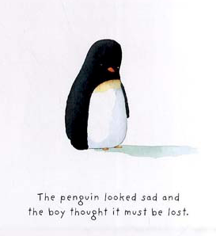

In Lost and Found the boy thinks that the penguin is sad because he is lost.
He wants to take Penguin back to the South Pole to make him happy.
In fact, the penguin is sad because he is lonely.
He wants to stay with the boy and be his friend.
Because he can’t speak, the penguin can’t tell they boy what he really wants.

You are going to write a story from the penguin’s point of view explaining what he then did to try and stop the boy from taking him to the South Pole.

1. Planning:
- Think of all the nice things the penguin could have done that would have made the boy want to keep him. Maybe the penguin cooked him lovely food, or made him something special? Maybe he did a fantastic drawing for him, or helped him with jobs around the house? Maybe he put on a party for the boy, or sang him a funny song?
- But what funny things would a penguin put in his cooking?! How helpful would he really be around the house? Would his song truly sound lovely to the boy?

Think of three things the penguin could have done for the boy.
Record them on your Story Planner.

2. Writing:
- Write out your story on pieces of special story paper.
- Use your very best handwriting to write your story.
- Use some examples of the progressive past in your writing: I was putting sardines into my cake mix, when the boy came into the kitchen. He looked a bit surprised so I made him a nice cup of fish scale tea.

Story Planner

I really wanted to stay with the boy so I...  But the boy still wanted to take me home to the South Pole so I... | But he still wanted to take me home so I... | The boy said I could stay with him forever!

A Remarkable Person

