What to do today
IMPORTANT! Parent or Carer – Read this page with your child and check that you are happy with what they have to do and with any weblinks or use of the Internet required.

1. Story time
Re-read Read the Hamilton Group Reader Why Not Me? by Ruth Merttens and Jackie Abey.

2. Using an apostrophe to indicate possession
Read the information on Possessive Apostrophes.
- Complete the exercises.
- Check with the Answers.

3. Writing out Woodpecker’s Story
Write out the story you have planned on pieces of lined paper or in a special mini book.
- Write your story in full, correctly punctuated sentences.
- Use your best handwriting.
- Add drawings to your story around the borders of your lined paper or on empty pages of your mini book.
- Read your story to your family.

Now try this Fun-Time Extra
- Do you ever go to the library or have a visit from a library van? What sort of books do you like to take out of the library?
- If you’ve run out books to read at home while the libraries are closed you can find lots of authors reading their stories online at the moment. Ask a grown-up if you can listen to some of these.
Kes Gray (including the Daisy and Oi! Books)
Oliver Jeffers (including the Day the Crayons quit series)
There are lots of different stories you can listen to in episodes of the CBeebies Bedtime Stories on IPlayer.
Mo Willems and Rob Biddulph have done draw-along sessions.

Using an apostrophe to show possession

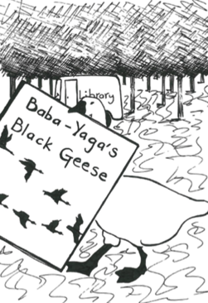

‘Possession’ means belonging to someone or something.
When we have or own something we say we possess it.

We can show that someone possesses something by adding an apostrophe (’) and an s to their name.

The black geese that belong to Baba Yaga are Baba Yaga’s geese.
Woodpecker’s tree is the tree that belongs to Woodpecker.
The wheels on the Library van are the van’s wheels.
The dog’s collar is the collar that the dog wears.

Showing possession, the apostrophe and s always come after the person’s name.

Woodpecker’s tree CORRECT
Woodpecke’rs tree NOT CORRECT
Woodpeckers’ tree NOT CORRECT

The apostrophe always goes high up between the name and the s,
not down on the line like a comma.

Woodpecker’s tree CORRECT
Woodpecker,s tree NOT CORRECT

Remember!
Plural words (when we have more than one of something) like dogs, cats, vans, trees, end in an s but do not need an apostrophe. There is no possession.

Three goats were in the story.

Possessive Apostrophes

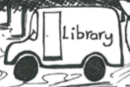

1. Highlight the possessive apostrophe +s in these sentences:

Woodpecker’s tail has red feathers.

Woodpecker looked at the fox’s eyes, which were glittering.

The book, which was Chicken Licken’s, looked heavy.

2. Add a possessive apostrophe in the right place in these sentences:

The mouses whiskers twitched with pride.

His tail was long, but not as long as rats tail.

The cat looked at the dogs paws with alarm.

3. Mark these sentences right or wrong depending on whether the apostrophe + s has been used correctly or not.

Woodpecker’s home is tidy and clean. ______________________________
It was time for the Library vans visit. ________________________________
Grasshoppe’rs legs are extremely long ______________________________
Hare,s ears hear everything. ______________________________________
It is time for Woodpecker’s story to be told! _________________________

Where it’s WRONG, rewrite the apostrophe word so that it is correct.
Now check with the Answers page to see how you did!

My Possessive Apostrophes – Answers

1. Highlight the possessive apostrophe +s in these sentences:

Woodpecker’s tail has red feathers.

Woodpecker looked at the fox’s eyes, which were glittering.

The book, which was Chicken Licken’s, looked heavy.

2. Add a possessive apostrophe in the right place in these sentences:

The mouse’s whiskers twitched with pride.

His tail was long, but not as long as rat’s tail.

The cat looked at the dog’s paws with alarm.

3. Mark these sentences right or wrong depending on whether the apostrophe + s has been used correctly or not.

Woodpecker’s home is tidy and clean. Right!
It was time for the Library vans visit. Wrong! van’s
Grasshoppe’rs legs are extremely long. Wrong! Grasshopper’s
Hare,s ears hear everything. Wrong! Hare’s
It is time for Woodpecker’s story to be told! Right!

Mini Story Books Instructions

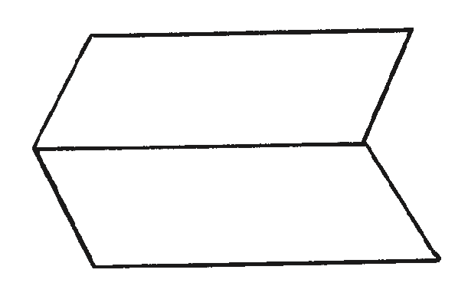
- Fold a sheet of paper in half lengthways and then unfold it.

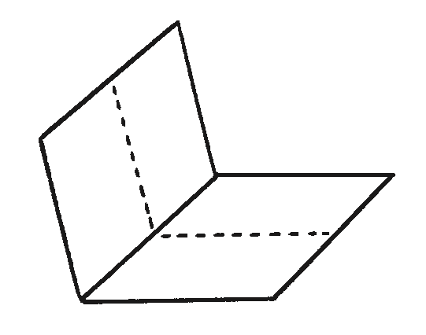
- Fold the same sheet of paper in half widthways and leave it folded.

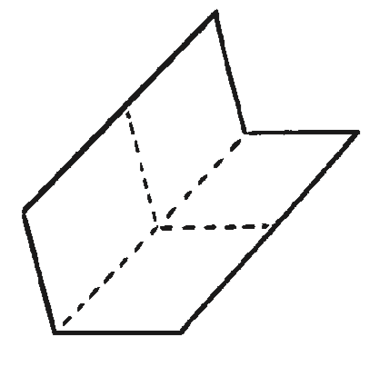
- Fold it in half again in the same direction and then unfold the last fold.

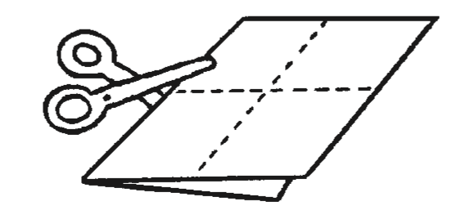
- Cut along the centre crease until you reach the middle of the piece of paper.

- Unfold the paper completely. There should be a slit through the middle of the paper. Fold the paper in half lengthways again and then push the two ends inwards towards each other to create a star shape with four arms.
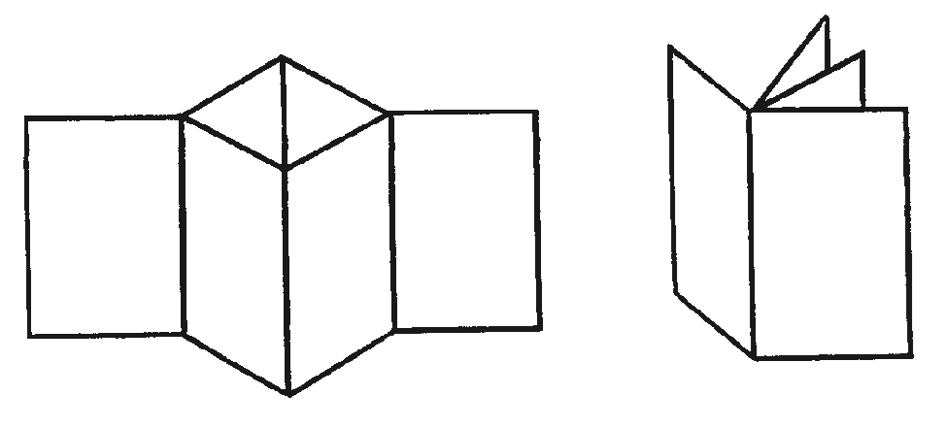

- The four arms are the pages of the book. Fold all of the arms around to face the same direction and the book is complete.

