What to do today
IMPORTANT! Parent or Carer – Read this page with your child and check that you are happy with what they have to do and with any weblinks or use of the Internet required.

1. Story time
Read the Hamilton Group Reader Why Not Me? by Ruth Merttens and Jackie Abey.

2. Answering questions
Look at the Questions about Why Not Me?
- Read each question.
- Think carefully about your answers.
- Write your answers neatly in the spaces provided.
- Check your work.

3. Planning Woodpecker’s story
You are going to plan and write a story about Woodpecker.
Read the Instructions for Planning Woodpecker’s Story.
- Record all your ideas on the Woodpecker Story Planner.

Now try these Fun-Time Extras
- Find out more about woodpeckers at https://www.rspb.org.uk/birds-and-wildlife/wildlife-guides/bird-a-z/woodpecker-family/ . You could sketch a picture of your favourite one.
- Have you ever seen or heard any woodpeckers near where you live?

Questions about Why Not Me?

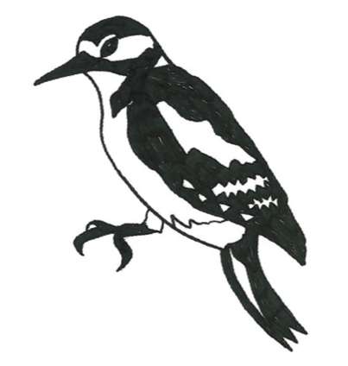

For what reason do all the animals come to the edge of the wood?
______________________________________________________________

Which is the second animal featured in the story?

______________________________________________________________

‘There’s never any fairy stories or tales about Woodpeckers,’ he complained.

Which of these words is closest in meaning to complained? Tick your answer.

giggled _____________
grumbled ___________
whispered __________
yelled ______________
stuttered ___________

‘Not as many as the stories about WOLVES!’ He growled again. ‘Remember, I am the one that is BIG and BAD.’

Why are the words WOLVES, BIG and BAD written in capital letters?

____________________________________________________________________________________________________________________________

Which of these animals is not in the story? Tick your answer.

Chicken ___________
Hare______________
Frog______________
Squirrel ___________
Fish ______________

In your own words, what would you say Hare thinks of Rabbit?
____________________________________________________________________________________________________________________________

What in the story makes you think that?
__________________________________________________________________________________________________________________________________________________________________________________________

Write a caption to go with this picture. (Don’t just copy the words from the story.)
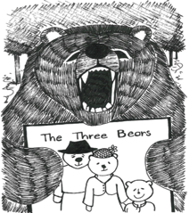
______________________________________________________________

Of all the fairy stories and tales shown in the story, what is your favourite?

______________________________________________________________

Why do you like that story the best?
__________________________________________________________________________________________________________________________________________________________________________________________

Instructions for Planning Woodpecker’s Story

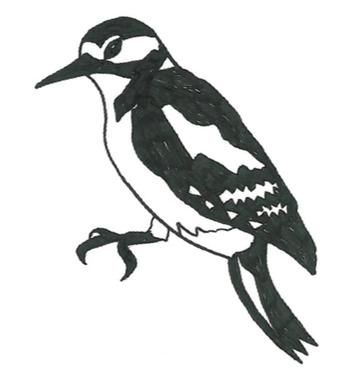

You are going to write a story all about Woodpecker.

Your story is going to have three parts:
- a beginning where Woodpecker is having a normal morning in the forest
- a middle part where he has a problem
- an end part where the problem gets solved

Think about what you want to put in your story.

In the beginning bit, what very normal things is Woodpecker doing?
Here are some suggestions: tidying his tree house; flying around delivering messages; pecking a dead tree to find food.

For the middle part, what sort of problem could occur?
Here are some suggestions: the wind blows down the tree where his house is; he gets lost in a distant part of the forest; he gets stung by an angry wasp…

In the end, how does the problem get solved?
Here are some suggestions: his friends all help him move to a new house and it’s lovely; a friendly Badger helps him get back home; Owl persuades the bees to say sorry... and puts a bandage on Woodpecker’s sore wing!

Record all your brilliant ideas as notes on the three-part Story Planner.
Woodpecker Story Planner

Beginning: Woodpecker’s ordinary day | Middle: The problem that occurs | End: How the problem is solved

Possible Answers - Questions about Why Not Me?

For what reason do all the animals come to the edge of the wood?
They have come to change their books at the library van.

Which is the second animal featured in the story?
The fox is the second animal featured in the story (the woodpecker is the first).
‘There’s never any fairy stories or tales about Woodpeckers,’ he complained.
Which of these words is closest in meaning to complained? Tick your answer.
grumbled _____ ✔______

‘Not as many as the stories about WOLVES!’ He growled again. ‘Remember, I am the one that is BIG and BAD.’
Why are the words WOLVES, BIG and BAD written in capital letters?
These words are written in capitals to make them stand out and to show that the speaker would put emphasis on them as he says them. It also highlights the words from the stories where the wolf features - he is often referred to as the big bad wolf.

Which of these animals is not in the story? Tick your answer.
Squirrel ___✔________
In your own words, what would you say Hare thinks of Rabbit?
Answers will differ but will likely make reference to Hare thinking Rabbit is a bit annoying and / or a show-off.

What in the story makes you think that?
Answers should correspond with what the children have written above, it is possible they will refer to rabbit saying ‘story-tellers love me’ and also to the fact that Hare ‘grumbles’ and stresses that he is NOT Rabbit’s cousin.

Write a caption to go with this picture. (Don’t just copy the words from the story.)
Answers will differ.
Of all the fairy stories and tales shown in the story, what is your favourite?
Answers will differ.
Why do you like that story the best?
Children should follow up by explaining why they like the story they’ve chosen the best, e.g. I like the Tortoise and the Hare the best because the Tortoise isn’t a show-off like the Hare and he doesn’t give up even though he’s slow. I like the fact that he perseveres and wins the race in the end.

