What to do today
IMPORTANT! Parent or Carer – Read this page with your child and check that you are happy with what they have to do and with any weblinks or use of the Internet required. Please check whether you are happy for your child to follow the links on ‘Further Revolting Rhymes’, Roald Dahl’s re-imagined fairy tales have surprising and sometimes gory twists!

1. Story time
Go to https://www.youtube.com/watch?v=q738kKFuhgM.
Enjoy listening to the reading of Cinderella written by Roald Dahl (ends at about 5.14 mins).
- Say one way that Roald Dahl’s version is the same as the traditional story you have heard.
- Say one way in which it is different.

2. Revolting Rhymes
Roald Dahl’s Cinderella comes from a book called Revolting Rhymes.
- Look at Revolting... Rhymes!
- Suggest similar and opposite words for revolting.
- Identify the rhymes in the excerpt from Cinderella.
- Suggest other words that rhyme with the pairs you have found.

3. Explaining your opinion
Which do you prefer – the traditional Cinderella or Roald Dahl’s version?
- On My Favourite Cinderella, state your preference.
- Explain why you prefer the version you have chosen.
- Use the conjunctions because/as/since to introduce your explanations.

Now try this Fun-Time Extra
Ask a parent if you can use the links on Further Revolting Rhymes and listen to more of Roald Dahl’s versions of traditional tales.
Which did you like the best of all?
Revolting...

similar | opposite

...Rhymes!

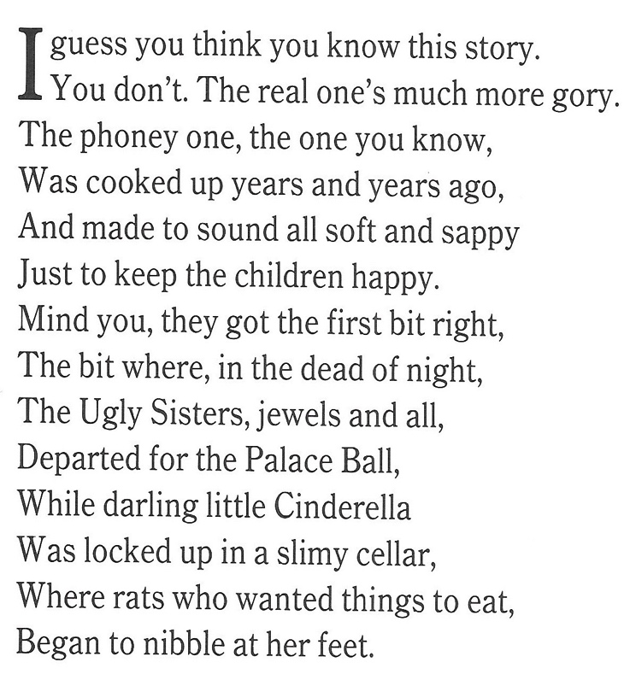
__________________________________________________________________________________________________________________________________________________________________________________________________________________________________________________________________________________________________________________________________________________________________________________________________________________________________________________________________________________________________________________________________________________________________________________________________________

1. Highlight the pairs of rhyming words in this extract from the story.
2. Next to each pair, write other words that would also rhyme with them.

My Favourite Cinderella
- the traditional version or Roald Dahl’s version?

because as since

My favourite Cinderella is ________________________________________

These are the reasons for my choice:

______________________________________________________________________________________________________________________________________________________________________________________________________________________________________________________________________________________________________________________________________________________________________________________________________________________________________________________________________________________________________________________________________________________________________________
The very best bit in my version is:
____________________________________________________________________________________________________________________________________________________________________________________

Further Revolting Rhymes

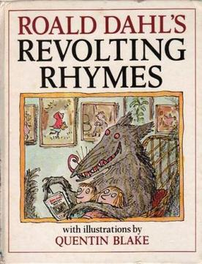

https://www.youtube.com/watch?v=F5DS2DnsJ04 – The Three Little Pigs
https://www.youtube.com/watch?v=CpAoCUN4toE – Jack and the Bean stalk
https://www.youtube.com/watch?v=zUlq2OA_Z0M – Snow White and the Seven Dwarves.

Which one did you like the most? What made it the best?

________________________________________________________________________________________________________________________________________________________________________________________________________________________________________________________________________________________________________________________________________________________________________________________________________________________________________

