- Health and Wellbeing | Year 6 Home Learning | - Geography/Art
Mindfullness  This week, we are looking at ‘thoughts’. Have a look at this video all about our thoughts. Remember….we are not our thoughts! https://www.youtube.com/watch?v=0QXmmP4psbA | Home Learning – Week 13  Topic: Beyond the Town  This week, we will be finishing lots of projects in class including our board games, learning about trading and finalising our Yearbook…it’s going to be a busy one! | Board game  In class, we are busy finalizing our board games. This week, we are working on the instructions. Can you create informative and useful instructions either on the computer or handwritten?  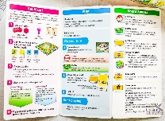
- Geography | - PSHE | - Forest School
Trade and Economics  On the website, download ‘UK imports and Exports’. Have a go at creating a bar chart to show how much the UK imports and exports different goods. | Transition  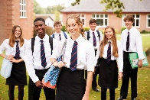  On the website, download the sheet ‘Learning about my Secondary School’. Go onto your new Secondary school’s website and have a go at answering the questions. Can you find out all of the answers? | Gold Medal  Using natural materials, can you create yourself a gold medal for your achievements at Forest School?
- Maths | - Art | - English
Golden Ticket Maths  Download ‘Maths – 15 minute Golden Ticket 2’ How many of these sums can you complete in 15 minutes? Check your answers afterwards with a calculator.  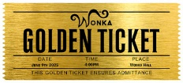 | Board Game Pieces  Use the salt dough recipe on the website to make counters for your board game. Cook them in the oven and paint!  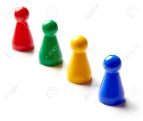 | Print your story from the website and add a front cover and illustrations. Try to make it fit for the bookshop!  