Year 1 English Home Learning Activities
Choose one activity from the grid to complete each day.

Perfect Friend  Draw a picture of a perfect friend. Write adjectives to describe your friend. What makes a perfect friend?  Challenge: Can you make a Thank you card for one of your friends? Why are they a good friend? | Poetry  Find a poem online that you enjoy reading.  Can you video yourself reading the poem using lots of expression?  Can you add any actions to your poem? | Handwriting  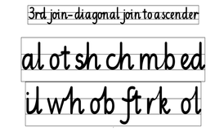  Practice some diagonal joins using the examples in the above picture.  Challenge: Can you write words including the letter blends above using joined up handwriting e.g. shell, lamb, when, chin?
Non-Fiction  Read a non-fiction book of your choice.  Write down 5 interesting things you found out from reading your non-fiction book.  Why did you find them interesting? | A-Z Animal list  Can you find one animal for each letter of the alphabet? Draw a picture of each animal.  Can you find out one fact about each animal you’ve written down? | Spelling  Practice spelling the days of the week.  Can you write down something you might do on each day of the week?  Example:  On Tuesdays, we have our PE lesson.

