What to do today
IMPORTANT! Parent or Carer – Read this page with your child and check that you are happy with what they have to do and with any weblinks or use of the Internet required.

NB You need the animal diary entry that was planned yesterday.

1. Story time
Read and enjoy Diary of a Kangaroo.
- Who causes more trouble – the wombat in Diary of a Wombat or the kangaroo here!?

2. Getting ready to write
- Read Studying the Diary of a Kangaroo. Identify features of recounts.
- Look for examples of Wombat’s Conjunctions being used to link ideas in sentences.

3. Writing time
Make a Mini Writing Book to write your animal diary entry from the plan you produced yesterday.
- Make sure you use the layout and language features of a diary.
- Keep your writing in the past tense. Try to include verbs in the progressive form of the past tense.
- Write in full sentences and use conjunctions to link ideas.
- If you have time, why not write the next day’s diary entry as well? What trouble will your creature cause then?

Now try this Fun-Time Extra
- Add pictures to your story and read it aloud to your family.
- Are your family glad they don’t have your animal living nearby?

Diary of a Kangaroo
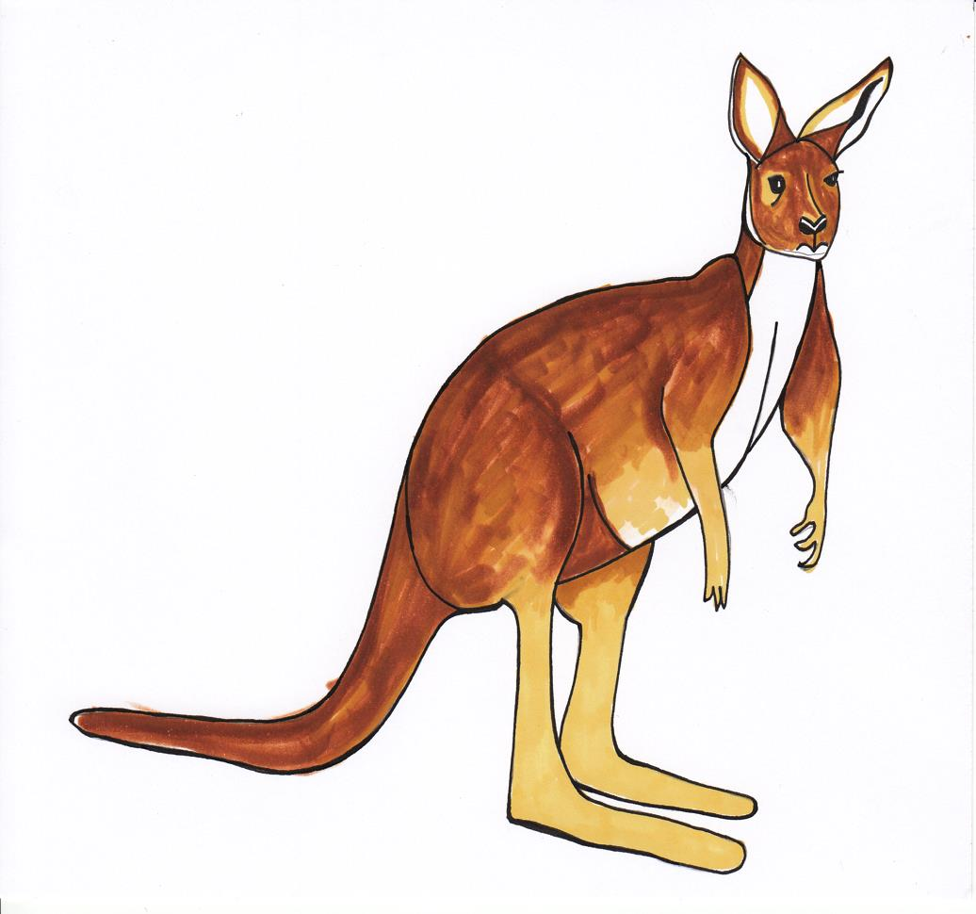

Wednesday

I woke up in the late morning after a good sleep under the trees and decided to bounce over to the nearest house to see what was happening.

The family have a swimming pool in the garden and I thought it would be a great idea to jump in for a quick wash. Ker-sploosh! The water was feeling so cool and refreshing, although a lot of it splashed out, which left the pool half empty. Honestly, you would think that people would keep the right amount of water in their pools.

In the afternoon, I clambered out of the pool and walked towards the garage. Unfortunately, the water from the pool had made the garden very muddy, so I was leaving a dirty trail all the way across the grass. Really, I thought, people should put paths in their gardens. It would make life much easier.

There was a very smart looking car parked on the drive. With one bounce, I was sitting on its bonnet. I was gazing out at the view for quite a while because it looked so beautiful. Suddenly, strange creaking noises began to come from underneath the car and – crack! – two of the wheels fell off. Well! I was thinking to myself that it wasn’t a very well-made car, when I heard a noise.

The family appeared at their gate. They were shouting and pointing at me. I couldn’t understand a word they were saying but they seemed to be very excited about something. I didn’t have time to stop and talk to them so I bounded off, giving them a cheery wave good bye.

What a fun day. Now, I wonder what I will do tomorrow?

Studying the Diary of a Kangaroo

Look carefully back at the diary

- Is it clear which day the diary entry is for? Can you see?
Yes. It says the day at the top of the page.

- Does the diary go in chronological order, starting in the morning and ending at night-time?
Yes, it starts in the morning when the family are at work, and continues through the day until the family come home in the evening.

- Find some of the verbs in the diary entry. Find your own and look at these.
- Are most verbs in the simple past tense? Find examples. See these and look for your own.
spent
splashed
woke up

- Can you find examples of the progressive past form? See these and find one more of your own.
was leaving
was happening

- Look for examples of Wombat’s Conjunctions being used to link ideas in sentences. Which conjunctions did you find being used in this way?
Circle any of these below that you found.

and but although so which because when since
Wombat’s Conjunctions
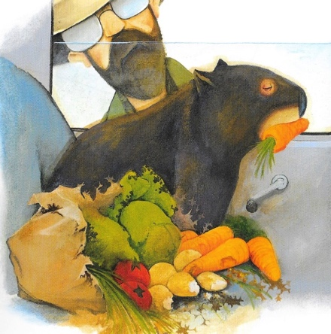

and but while when because

although since as so

Mini Story Books Instructions

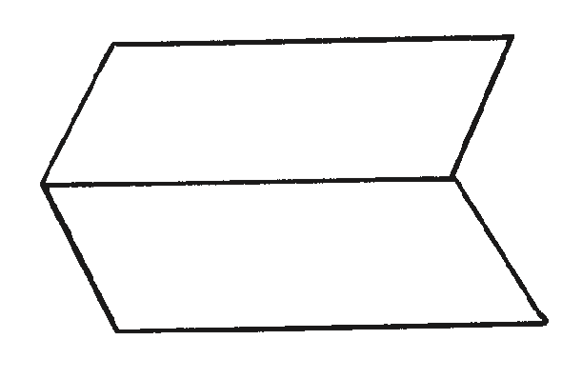
- Fold a sheet of paper in half lengthways and then unfold it.

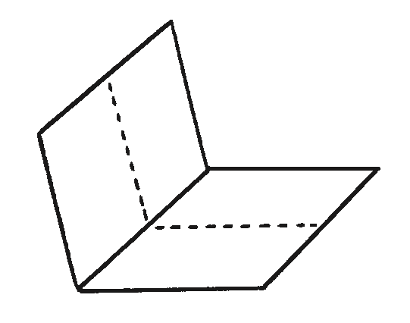
- Fold the same sheet of paper in half widthways and leave it folded.

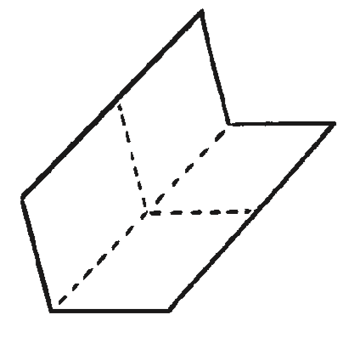
- Fold it in half again in the same direction and then unfold the last fold.

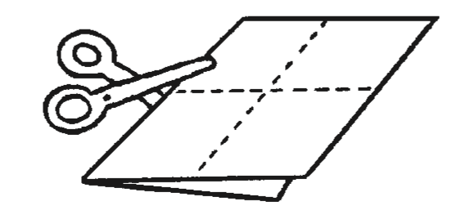
- Cut along the centre crease until you reach the middle of the piece of paper.

- Unfold the paper completely. There should be a slit through the middle of the paper. Fold the paper in half lengthways again and then push the two ends inwards towards each other to create a star shape with four arms.
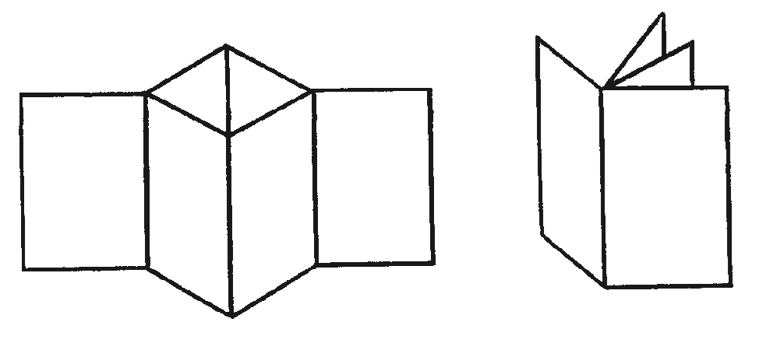

- The four arms are the pages of the book. Fold all of the arms around to face the same direction and the book is complete.

