What to do today
IMPORTANT! Parent or Carer – Read this page with your child and check that you are happy with what they have to do and with any weblinks or use of the Internet required.

NB You will need to keep your plan for your diary entry for tomorrow’s lesson

1. Story time
Go to https://www.youtube.com/watch?v=0esdaXtf0Yo&t=334s and listen to a different reading of Diary of a Wombat.
- Which reading of the story did you like most?
- Give reasons as to why you prefer your choice.

2. Using conjunctions to join ideas
Read the set of Conjunctions.
- Now read the pairs of sentences on Wombat’s Busy Day.
- Rewrite each pair of sentences as one full sentence with a conjunction linking the two parts. Check with the set of Possible Answers.

3. Planning to write a new story
Tomorrow, you are going to write the diary entry of an animal who causes all sorts of trouble for a family. Today you will plan your story.
- Decide which animal will feature in your story. Record this on My Animal Diary Planner.
- Decide which day of the week your diary entry will be for.
- Have fun thinking of the three things your animal does that cause big trouble for the family.
- Look at the Diary Suggestions for some ideas if you get stuck.

Now try this Fun-Time Extra
- Wombat gets into all sorts of trouble with the family. Maybe have a look with a grownup at some other naughty animals. E.g. https://www.youtube.com/watch?v=QpNXHJGfGYo

Wombat’s Conjunctions
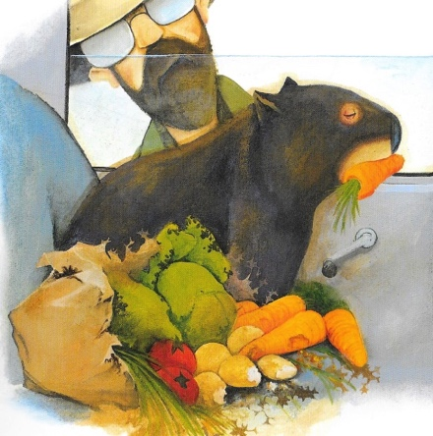

and but while when because

although since as so

Wombat’s Busy Day
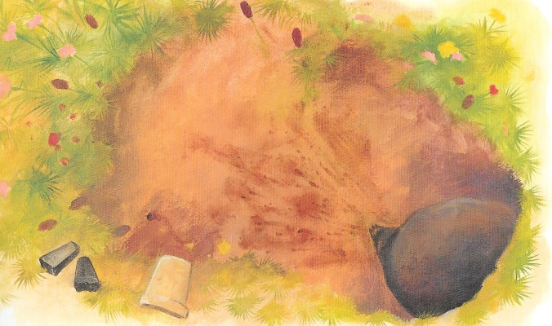
- Rewrite each pair of sentences as one full sentence with a conjunction linking the two: In the morning I slept. At lunchtime I ate grass
Turns into: In the morning I slept but at lunchtime I ate grass.
- Watch out – your sentence has to make sense so you will need to choose your conjunction with care.
- Use a new conjunction each time.

In the morning I slept. At lunchtime I ate grass.
I was banging on the dustbin. The humans came running out of the house.
I liked my new hole. It was warm and dry.
I chewed a nice big gap in the door. Suddenly the family appeared, looking cross.

Wombat’s Busy Day – Possible Answers

In the morning I slept and /but/ while/ although at lunchtime I ate grass.
I was banging on the dustbin and /when/ so the humans came running out of the house.
I liked my new hole and / because /since /while / when it was warm and dry.
I chewed a nice big gap in the door and / but / when suddenly the family appeared, looking cross.

My Animal Diary Planner

My diary will be written by a
The day of the week for the diary will be
These are the three troublesome things my animal does: | 1.  2.  3.
This is what happens at the end of the day:

Diary Suggestions

Some things your animal might do wrong:
Your diary could be written by ANY animal you want.  It could be written by an animal you know like a dog or a cat, a squirrel or a garden bird.  Or it could be written by another Australian animal, like a kangaroo, a possum or a platypus, an echidna, a cassowary or a kookaburra.  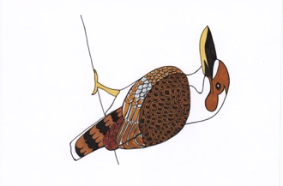  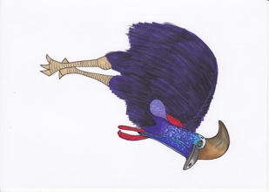  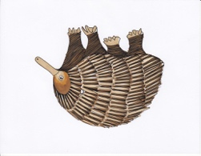  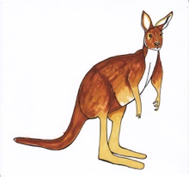  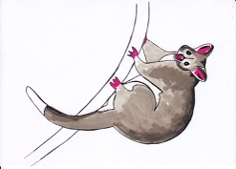  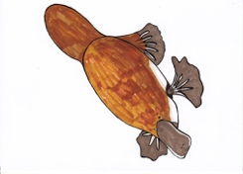 | Break something valuable  Knock something special over  Leave tooth, beak or claw marks on something precious  Get mud or water on something clean  Eat or drink something being kept for a special occasion  Make a lot of noise when it is quiet  Leave fur or hair in the wrong place  Make a horrible smell!

