Maths Learning Activities – choose one a day and email me your work.
Prime and Composite  Sort these numbers:  2, 3, 4, 5, 6, 7, 9, 10, 11, 12, 13, 14, 15, 16, 17, 19  Prime:  Composite: | Roman Numerals Part 3  Answer these questions – use Roman Numerals in your answer!  XV + V =  XXX + XX =  X – V =  L – X =  C – X = | Rounding Numbers  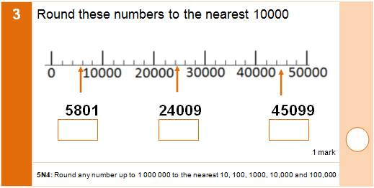
Metric and Imperial Units  Convert these measurements:  1 metre = _______ inches  1 gallon = ______ litres  1kg = __________ pounds  1 inch = ________ centimetres | Google Maps  Use google maps to locate places you have been to and find the distance travelled.  Put the distances in order from longest to shortest. | Measuring  Find a range of items, with different weights.  Estimate the weights and put them in order from lightest to heaviest.  Now weigh the items. What are the actual weights? Do you need to change the order?

