Year 1 English Home Learning Activities
Choose one activity from the grid to complete each day.

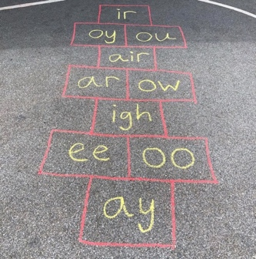  Play phonics hopscotch in your garden: | Word finder:  Look through a book. Can you find any words longer than 7 letters? What is the longest word you can find? Write it down. | https://www.oxfordowl. co.uk/for-home/  Choose a book to read to an adult at home.
Read the story ‘Tiddler’:https://www.youtube.co m/watch?v=pBRT5vsfE3U  Tiddler likes to make up stories about why he is late for school. can you make up a story about why he is late? | Your own adventure:  If you went on an adventure, where would you go?  The sea? Space? A different country?  What would you see? How would you get there? | Practice writing some Spelling Bee words in ‘curly cursive’.
Positive adjective star!  You are all amazing stars.  Write your name in the middle of a star – fill your star with all the adjectives that describe you. | Write a shopping list of all your favourite foods. Can you draw pictures for each of them? Write a sentence using ‘because’ to explain why they are your favourite food. | Read ‘The Lion Inside’: https://www.youtube.co m/watch?v=GlfDD3gYZ_0  Can you write a description of the lion on the inside and on the outside?

