What to do today
IMPORTANT! Parent or Carer – Read this page with your child and check that you are happy with what they have to do and with any weblinks or use of the Internet required.

1. Story time
Read and enjoy the monster poem, The Alien.
- Why do you think the alien laughs and laughs when he sees the person in the poem?
- Could it be because the person looks really funny to the alien?

2. Similes
Now use the information on Similes to identify the simile used in The Alien. (The alien was as round as the moon.)
- Look at the set of four Monster Pictures. Choose one.
- Draw four labels around the picture.
- Compose simile phrases to label different things about your choice of monster. Eyes as big as saucers; a tongue like a long pink sausage.
- Use examples of both as...as and like similes in your labels.

3. Writing time
Read The Alien for the last time.
- You are now going to write two paragraphs about another alien who comes to visit the Earth.

Now try this Fun-Time Extra
- Spot the ‘odd word out’ in sets of words linked to aliens and monsters. Create own ‘odd word out’ puzzles for Mums and Dads to solve.
The Alien

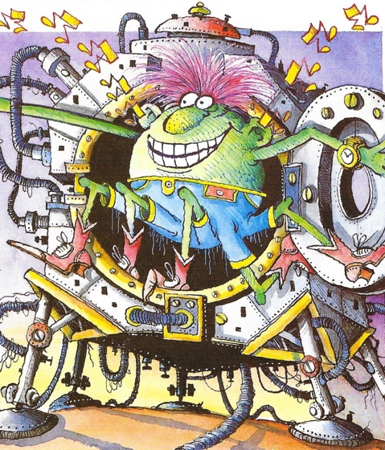

The alien
was as round as the moon.
Five legs he had
And his ears played a tune.
His hair was pink
And his knees were green,
He was the funniest thing I’d seen
As he danced in the door
Of his strange spacecraft,
He looked at me –
And laughed and laughed!

by Julie Holder
From Monster Poems by John Foster and Korky Paul

Similes

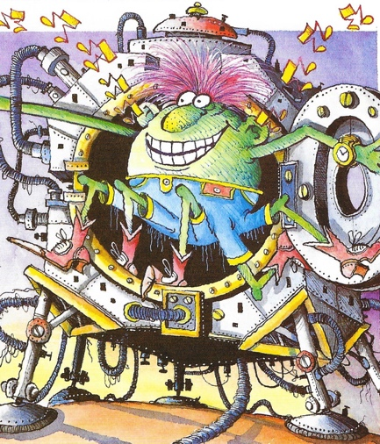

Similes are a special kind of comparison in writing. We can use similes to describe something by comparing it to something that it is similar too.

There are two ways we can do this.

1. We can say what the thing we are describing is like.

The monster’s eyes rolled around like golf balls.

The alien jumped down from his flying saucer like a leopard.

Or

2. We can compare the thing we are talking about by using the word as, twice.

The monster’s eyes were as white as whale blubber.

The alien jumped out of the water as quick as a flash.

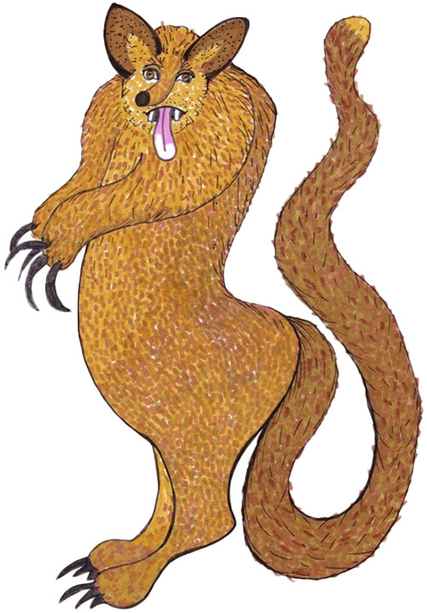

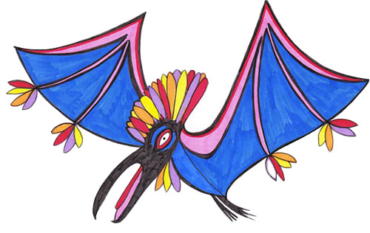

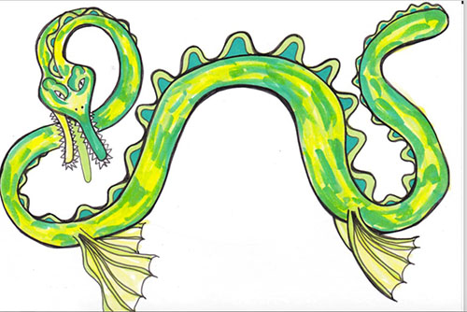

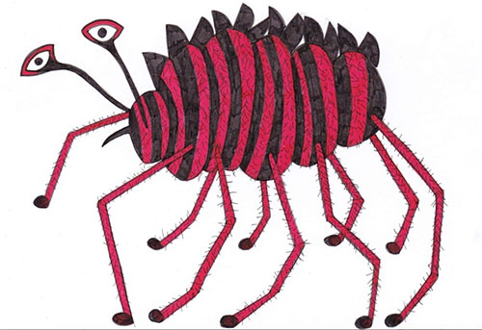
The Alien who came to visit earth
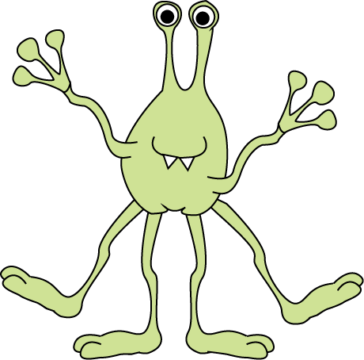

Advice on writing about it.

Make paragraph 1 a description of your creature.

- Use adjectives and adverbs as well as similes in your sentences.
huge green eyes...;
really long thin legs; hair like writhing snakes....

Make paragraph 2 about what the alien gets up to on its visit.

- Use prepositional phrases in your sentences.
It reached under the bed...;
It jumped clean over the house....

The Alien who came to visit earth

Odd Word Out

Which is the odd word out in this group? Can you say why?

roast freeze scorch burn toast

Now try this set. Again, can you say your word is the odd one out?

roar whisper howl yell cry scream

Make up some odd word out puzzles for your family. They could be about monsters or anything else you like.

