What to do today
IMPORTANT! Parent or Carer – Read this page with your child and check that you are happy with what they have to do and with any weblinks or use of the Internet required.

1. Prepositions and prepositional phrases
Open the PowerPoint, Noun Phrases 2.
- Read through it looking at prepositions and prepositional phrases.
- Complete the exercise on slide 6.
- If it is not possible to watch the PowerPoint, revise prepositional phrases by looking at the Revision Card.

2. Poem reading
Read and enjoy the monster poem, The Glamdrack.
- Highlight the prepositional phrases in the poem. There are 9 to find.
- Check on the Answers copy of the poem. How many did you get?
- Highlight any remaining prepositions that you didn’t find first time.

3. It’s writing time
Look at the ‘creature feature’ sentence starters on Monster Mash Up.
- Read each sentence starter.
- Using those listed on Prepositions to get you started, add a prepositional phrase to each starter. The vampire flew through the open window.
- Use one of the phrases you have created as the beginning of a monster story.
- Carry on writing the story, using as many prepositions as you can in your sentences.

Now try this Fun-Time Extra
- Add monster pictures to your Monster Mash Up sentence starters page.

Revision Card
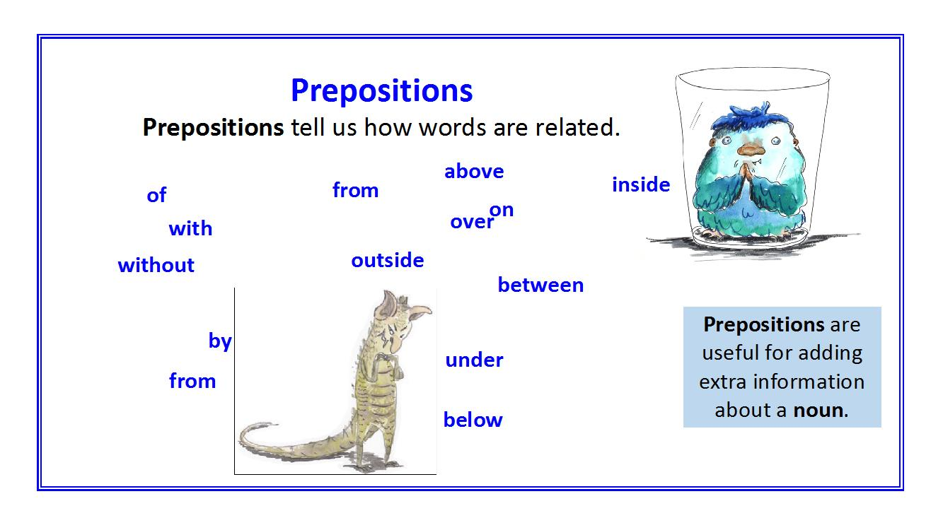

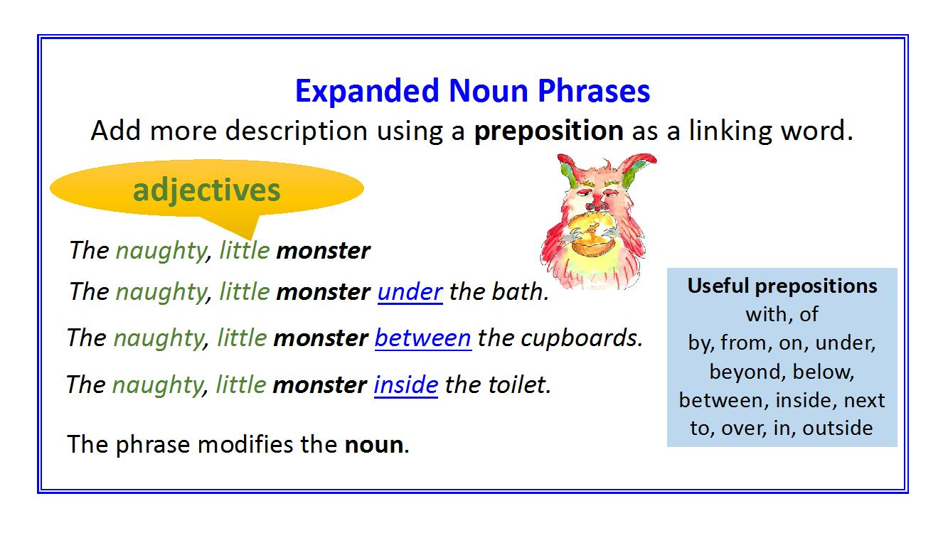

The Glamdrak

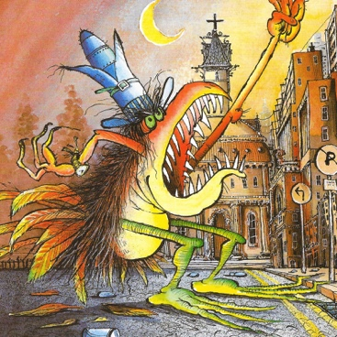

Over the hill the Glamdrak came,
its claws were large,
its eyes aflame.

Across the fields the Glamdrak strode,
straddled the fence,
and stood on the road.

Into the town the Glamdrak walked,
with poisoned breath
its quarry it stalked.

In the square the Glamdrak paused,
and screeched its fury
at all the locked doors.

Past the church the Glamdrak went,
into the distance
its anger spent.

by Robin Mellor
From Monster Poems by John Foster and Korky Paul

The Glamdrak – Prepositional Phrases
Answers

Over the hill the Glamdrak came,
its claws were large,
its eyes aflame.

Across the fields the Glamdrak strode,
straddled the fence,
and stood on the road.

Into the town the Glamdrak walked,
with poisoned breath
its quarry it stalked.

In the square the Glamdrak paused,
and screeched its fury
at all the locked doors.

Past the church the Glamdrak went,
into the distance
its anger spent.

by Robin Mellor
From Monster Poems by John Foster and Korky Paul
Monster Mash Up

The vampire flew __________________________________________________________________________________________________________
The monster hid ___________________________________________________________________________________________________________
A werewolf growled ________________________________________________________________________________________________________
The yeti jumped ___________________________________________________________________________________________________________
Frankenstein’s monster ran __________________________________________________________________________________________________
Some alien creatures swam __________________________________________________________________________________________________
The Loch Ness Monster crawled _______________________________________________________________________________________________
One robot smashed ________________________________________________________________________________________________________

Prepositions

in on under between beside with
next to through above inside on top of
towards along down at to across
beyond past beneath below within

