What to do today
IMPORTANT! Parent or Carer – Read this page with your child and check that you are happy with what they have to do and with any weblinks or use of the Internet required.

1. Story time
Read and enjoy the story, Wild Pets.

2. Answering Questions
Look at the set of Wild Pet Questions.
- Carefully read each question.
- Write your answers neatly in the spaces provided.

3. Writing time
You are going to write a story about a pet and what it gets up to at night time. Today you will plan your story.
- Use the Story planner to write your ideas in each section.
- If you get stuck or not sure what to do, look at the Example Planner.

Now try this Fun-Time Extra
- Look at Night. How many other words spelt -ight can you collect?
- Write sentences containing your words. I got a really big fright.
- Can you get more than one of your words into the same sentence? I got a fright at night when I put on the light. What a sight! There was a bright green frog having a fight with a beetle all slender and slight.

Wild Pet Questions
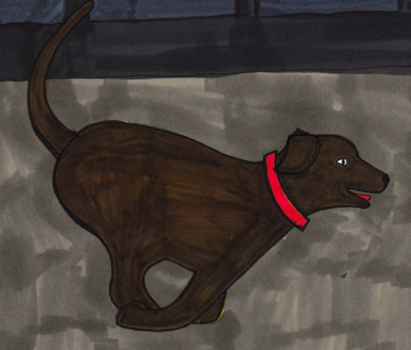
- Explain what a ‘pet’ is.
_______________________________________________________________

- Match the owner to their pet by drawing lines between the correct pairs.
Matt | dog
Bella | rabbit
Sunil | cat
Mia | fish

- In your own words, say what things Bella and her cat get up to during the day.
________________________________________________________________________________________________________________________________

- Circle all the words in the set that you think describe the rabbit in the story.
loving ferocious cruel gentle quiet dangerous

- Find and copy the line in the story that explains the thing that Sam’s pets really like.
________________________________________________________________

- Explain one thing you think Sunil’s dog and his friends might do when they go wild at night.
________________________________________________________________________________________________________________________________________________________________________________________________________________________________________________________________

- All the pets in the story change and become wild at night. But which pet seems to change the most when they become wild?
________________________________________________________________________________________________________________________________

- Do you think the pets really turn into wild animals at night?
_______________________________________________________________________________________________________________________________________________________________________________________________

Story Planner

- Begin by recording the name of the child who is going to be in your story.
- Decide what very normal pet they have and list some ordinary things the pet does in the day.
- Then have fun thinking up amazing and crazy things it could get up to at night when it has gone wild!

1. The child in my story is called: | 2. Their pet is:
3. Some very ordinary things the pet does during the day: | 4. The wild and amazing things it does at night:

Example planner

1. The child in my story is called:  Oli | 2. Their pet is:  Pog the hamster
3. Some very ordinary things the pet does during the day:  Sleeps quietly in a box filled with old wool  Goes on his wheel  Eats seeds and a piece of carrot  Sometimes roll round the house in a ball | 4. The wild and amazing things it does at night:  Gets out of his cage  Pushes through the cat flap and out into the garden  Meets up with other hamsters from the street  They all climb the trees in the garden, dig burrows, chase the mice and scoff all the salad in next door’s veg patch!

Night

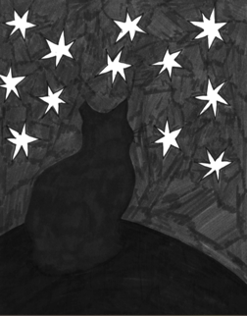

Collect some -ight words here

might

_______________________________________________________________________________________________________________________________________________________________________________________________________________________________________________________________________________________________________________________________________________________________________________________________________________________________________________________________________

