English Learning Activities – choose one a day and email me your work.

Summer Theme: Beyond The Town!
Fictional Character  If you could have any fictional character as your best friend, who would you choose and why? What would you do together? | Superpowers  If you had one superpower, what would it be? Explain why you have chosen that superpower, what you would do with it and how it would change your life. | Library, Museum or Zoo?  If you were forced to spend the rest of your life in a library, a museum or a zoo, which would you choose and why?
Planets  You just discovered a new planet. Tell the story. | Tiny Turtle  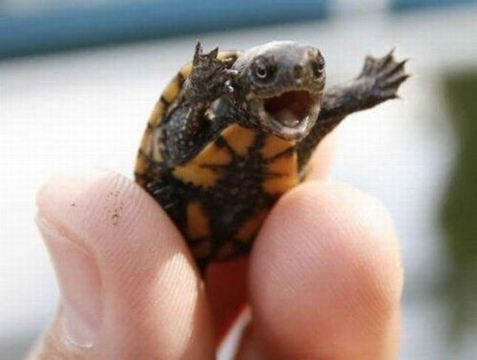  This tiny turtle is giving a speech. What is he saying? Who is he speaking to? | Spider Car  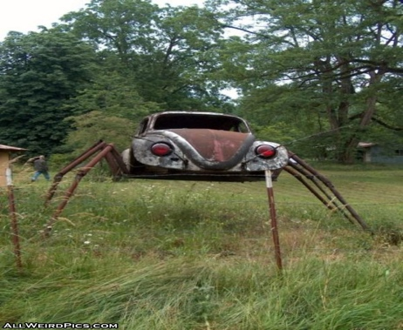  A new type of car has just been invented: The Spider Car. Write about its cool features. Then design your own new type of car.
Animal Kindness  What can humans learn from animals? | My Drawings  You wake up in a world where all of your drawings have come to life. Tell the story. | Theme Park  Design your own theme park and write about it.
Book Review  Write a review about the book you have just read. | Inventions  Describe an invention or discovery that you would like to be known for. | School Rules  If you could change one rule at school, which rule would it be and what would you change it to? Why did you choose that rule? Why is your rule better than the old one?

