What to do today

IMPORTANT! Parent or Carer – Read this page with your child and check that you are happy with what they have to do and with any weblinks or use of the Internet required.

1. Reading time
Read the poem Dad and the Cat and the Tree by Kit Wright.

Sequence events in the poem
Cut up and shuffle the set of Dad Cat and Tree Picture Cards. o By reading the captions and looking at the pictures, place the cards in the correct order on the two empty grids.
o When you are sure you have got them in the right order, glue the pictures down. Number them 1 – 12. Later, colour your cards in and use them to tell someone else the story.

Writing time
What might happen next? How will Dad get out of the tree? Will someone have to go up to rescue him? o On What Happens Next draw what you think will happen now that the Dad is stuck in the tree.
o Write some sentences under your picture. Remember to use capital letters to start your sentences and full stops to finish them.

Dad and the Cat and the Tree

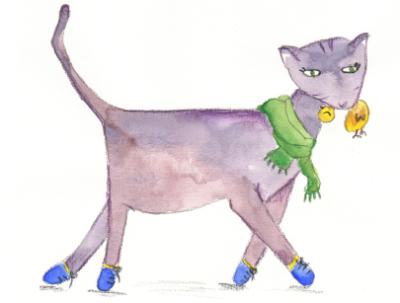
This morning the cat got Dad landed wallop Stuck in our tree, Back on the deck.
Dad said, “Right, just Mum said, “Stop it!”
Leave it to me.” You’ll break your neck!”

The tree was wobbly, ‘Rubbish!” said Dad.
The tree was tall. “Now we’ll try Plan C.
Mum said, “For goodness Easy as winking
Sake don’t fall!” To a climber like me!”

“Fall!” scoffed Dad, Then he climbed up high “A climber like me? On the garden wall.
Child’s play, this is! Guess what?
You wait and see.” He didn’t fall!

He got out the ladder He gave a great leap
From the garden shed. And he landed flat
It slipped. He landed In the crook of the tree trunk – In the flower bed. Right on the cat!

“Never mind,” said Dad, The cat gave a yell
Brushing the dirt And sprang to the ground,
Off his hair and his face Pleased as Punch to be And his trousers and shirt. Safe and sound.

“We’ll try Plan B. Stand So it’s smiling and smirking,
Out of the way!” Smug as can be,
Mum said, “Don’t fall But poor old Dad’s
Again, OK?” Still
“Fall again?” said Dad. Stuck
“Funny joke!” Up
Then he swung himself up The
On a branch. It broke. Tree!

by Kit Wright

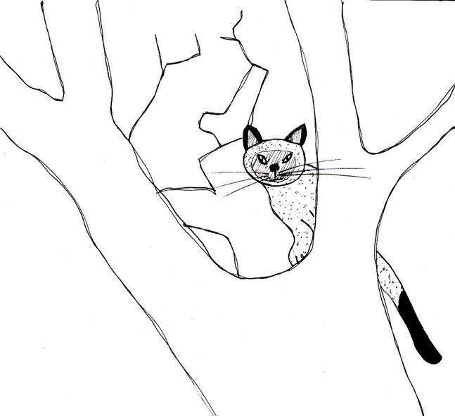  The cat is stuck in our tree. | 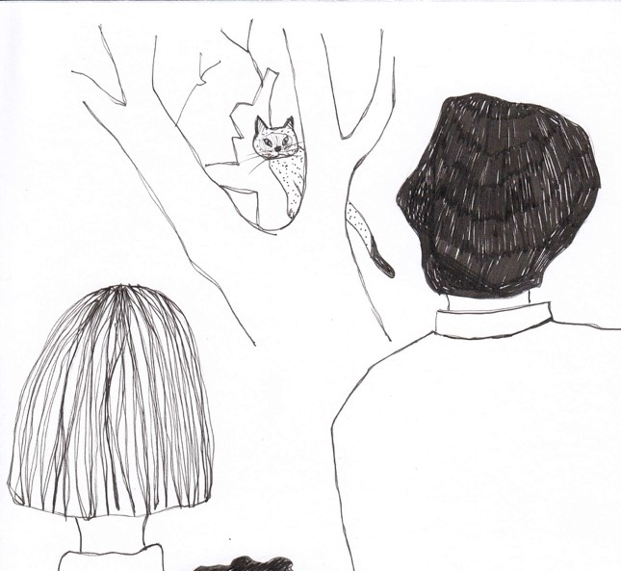  Mum, Dad and me are looking at it. | 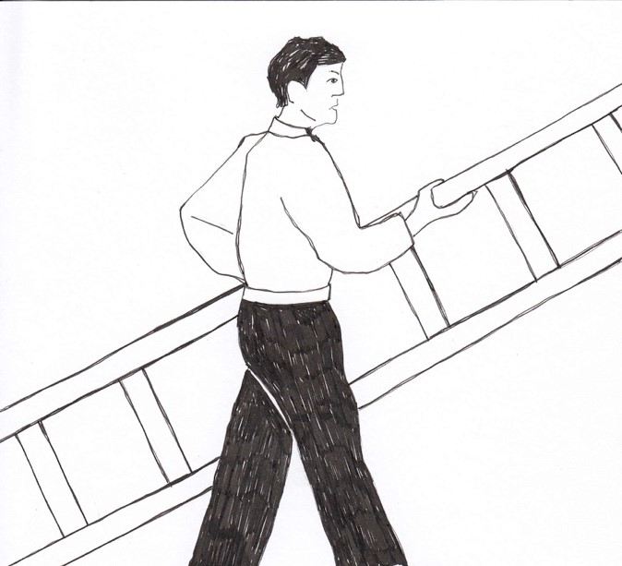  Dad gets a ladder.
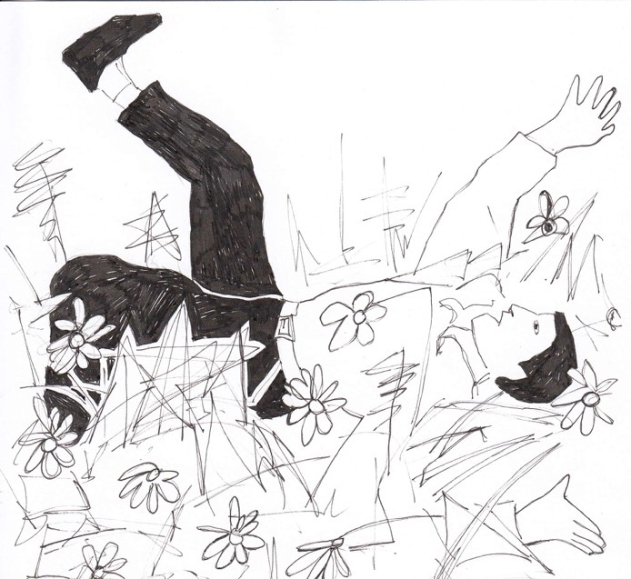  The ladder slips. | 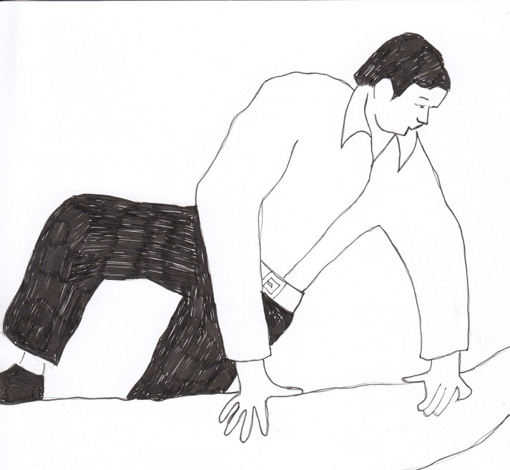  Dad climbs on a branch. | 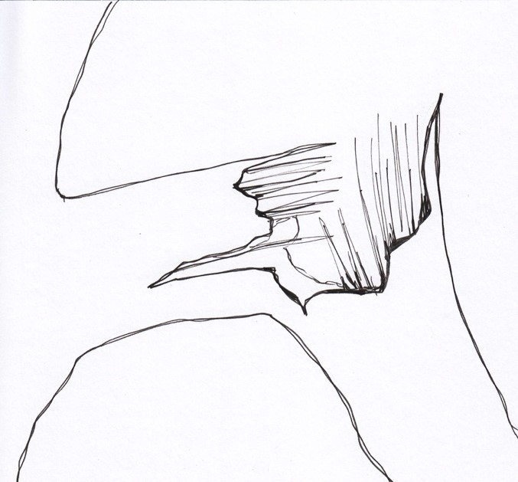  The branch breaks.

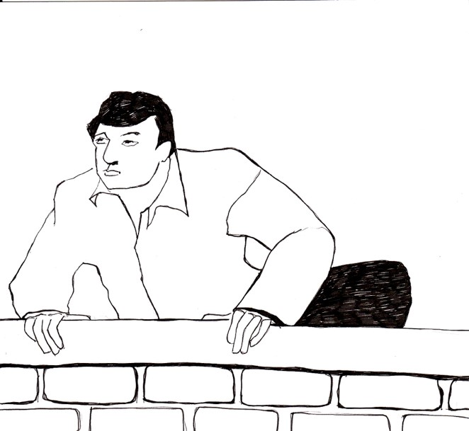  Dad climbs on the wall. | 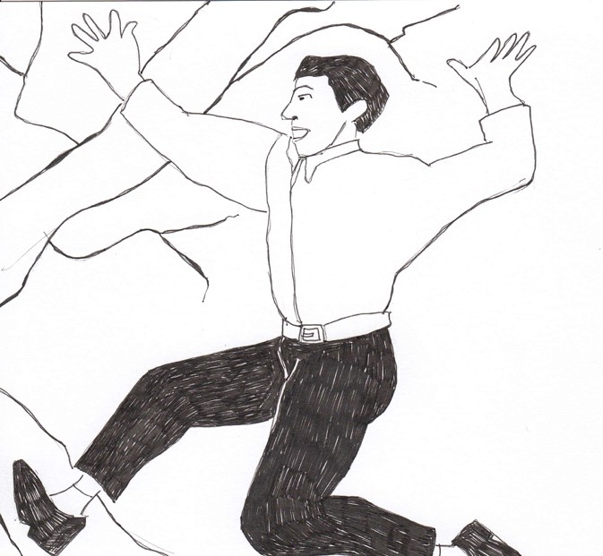  Dad jumps on to the tree. | 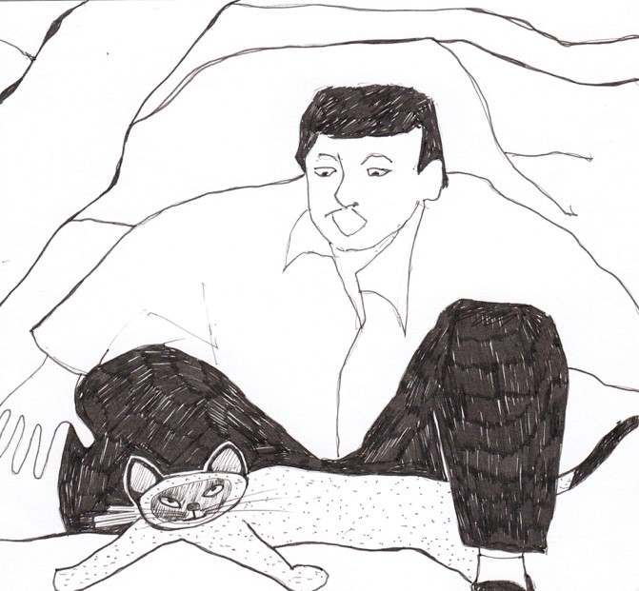  Dad lands on the cat!
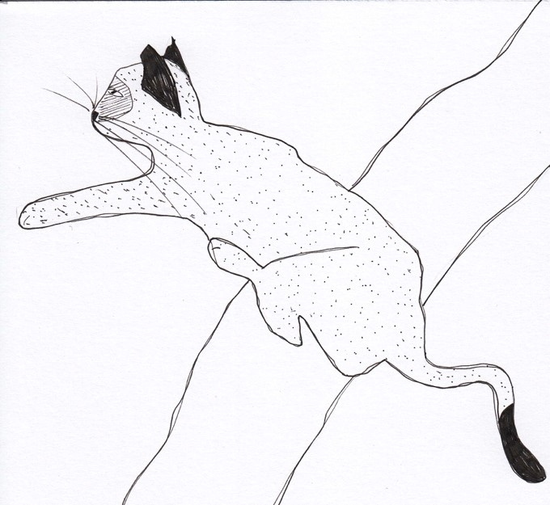  The cat jumps down from the tree. | 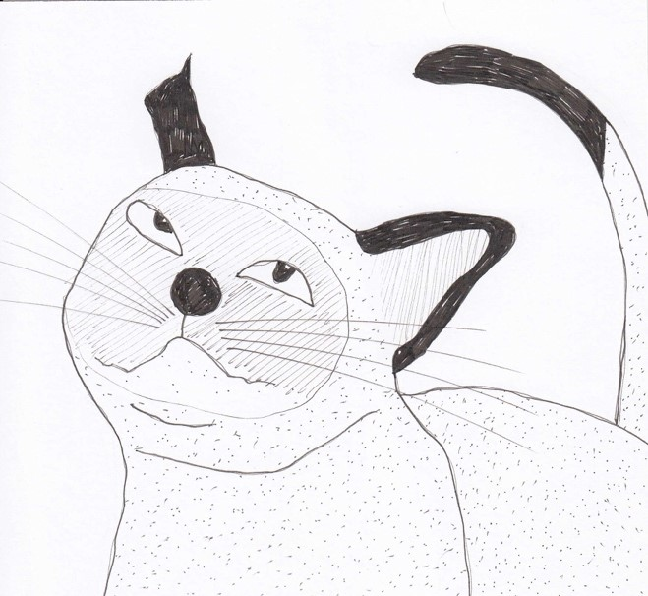  The cat is smug. | 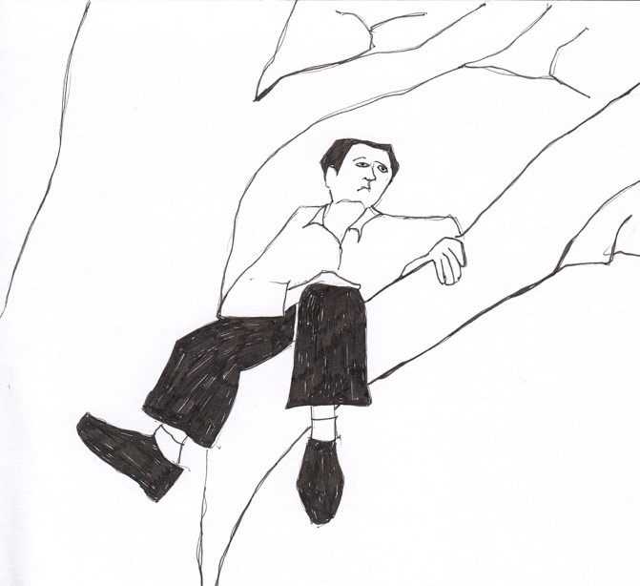  Dad is stuck up the tree.

What Happens Next

_________________________________________________________
_________________________________________________________
_________________________________________________________
_________________________________________________________

