Year 1: Week 3, Day 4
Add 10, 20 and 30
Each day covers one maths topic. It should take you about 1 hour or just a little more.
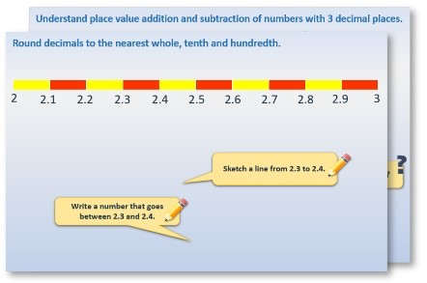
1.
Start by reading through the
Learning Reminders
.
They come from our
PowerPoint
slides.
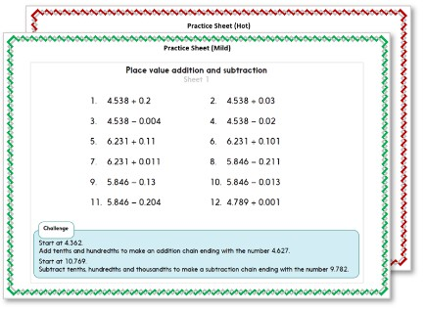
2. Tackle the questions on the Practice Sheet. There might be a choice of either Mild (easier) or Hot (harder)!
Check the answers.
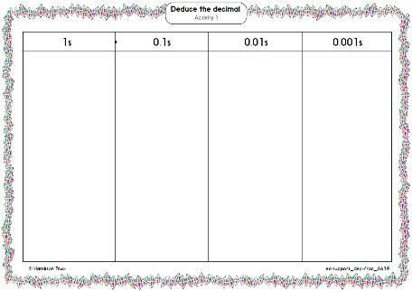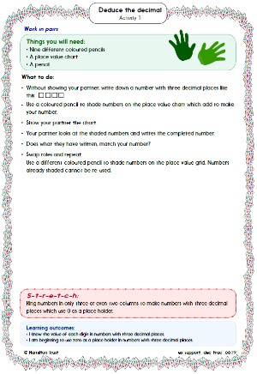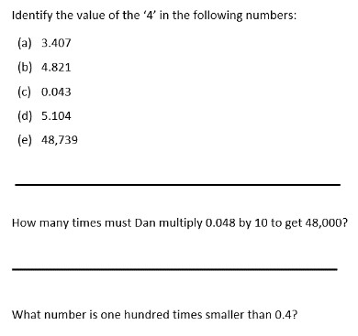
ã
Hamilton Trust
3.
Finding it tricky? That’s OK… have a go with
a
grown-up at
A Bit Stuck?
4.
Have I mastered the topic? A few questions to
Check your understanding
.
Fold the page to hide the answers!

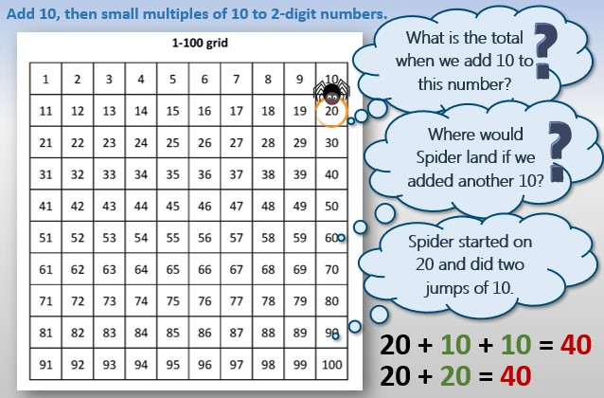

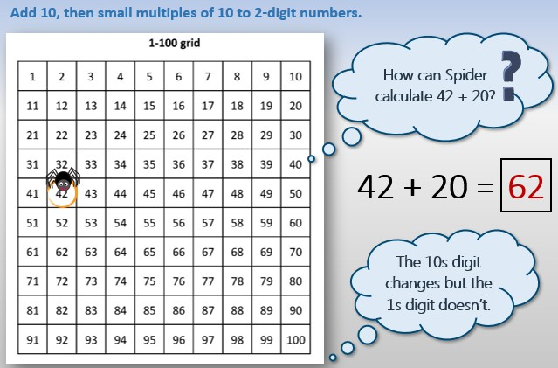

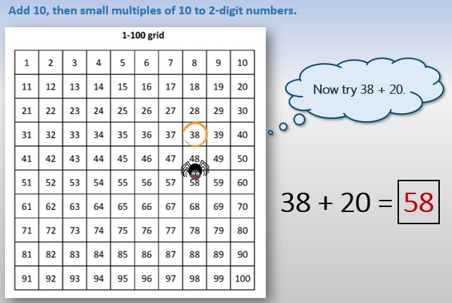

©
Hamilton Trust
©
Hamilton Trust
Practice Sheet Mild
Adding 10s
Pick a number from the sheet.
A
dd
20
to the number. Write the number sentence and use Spider to help find the
answer. Aim
for 10 different number sentences!
30
7
60
14
10
45
36
57
9
33
40
8
12
28
22

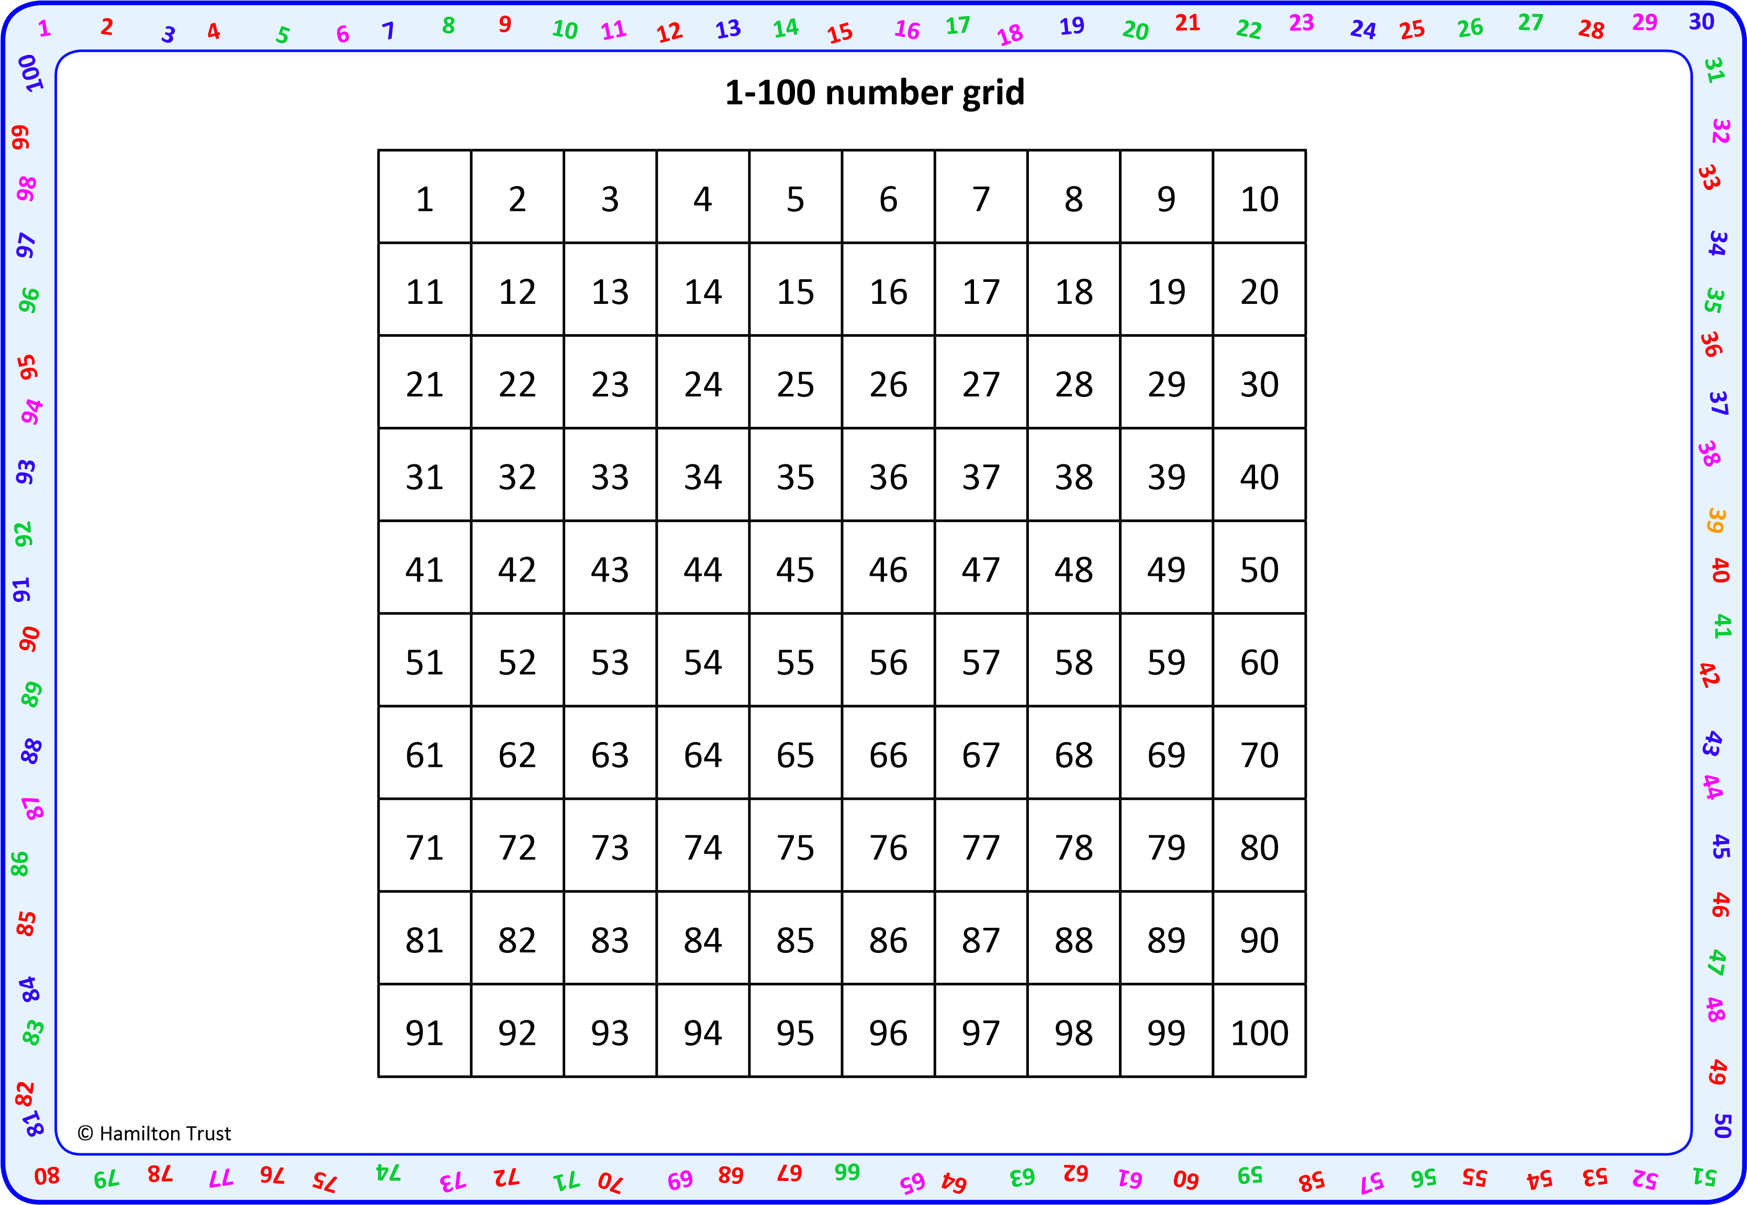

©
Hamilton Trust
©
Hamilton Trust
Practice Sheet Hot
Adding 10s
Pick a number from the sheet. Pick a tens card to add to the number. Write the number sentence and use Spider to help find
the
answer. Aim for 10 different number sentences!
30
7
60
14
10
45
36
57
9
33
40
8
12
28
22

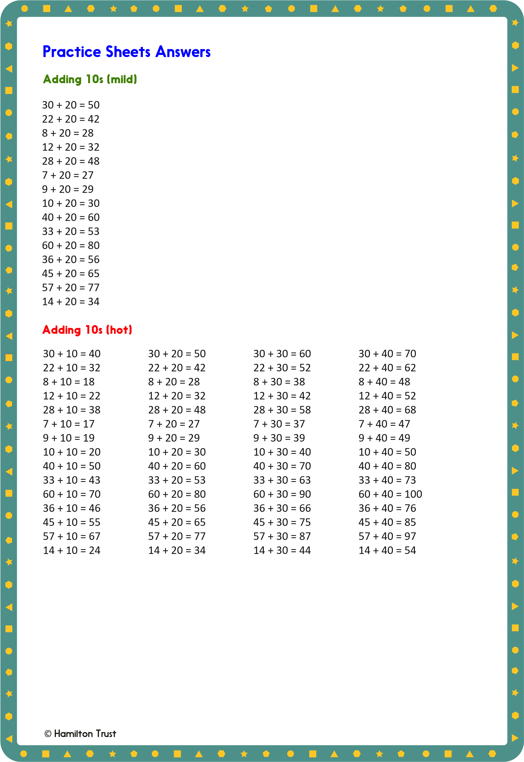

Check your understanding

Questions

True or false?

- 34 + 20 = 43
- 62 + 20 = 82
- Ten more than 55 is 66
- 85 = 50 + 30
- 65 + 20 = 67
- When you add a 10s number to a 2-digit number, both digits will change.

Write some ‘true’ additions to replace any above which are false.

Fold here to hide answers

Check your understanding

Answers

True or false?

- 34 + 20 = 43 False, 34 + 20 = 54.
- 62 + 20 = 82 True.
- Ten more than 55 is 66 False, 55 + 10 = 65.
- 85 = 50 + 30 False, 85 = 50 + 35 or 55 + 30.
- 65 + 20 = 67 False, 65 + 20 = 85
- When you add a 10s number to a 2-digit number, both digits will change.
False, only the 10s digit changes, e.g. 47 + 20 = 67 or 63 + 30 = 93.

Write some ‘true’ additions and subtractions to replace those above which are false.

Children can check these using Spider counting on a 1-100 grid. Errors can arise when children count on in 1s, rather than 10s, or include the starting number in the count, so saying, for example, 64 + 30 = 84.

ã Hamilton Trust

