Year 1: Week 3, Day 1
Pairs to 8 and 9
Each day covers one maths topic. It should take you about 1 hour or just a little more.
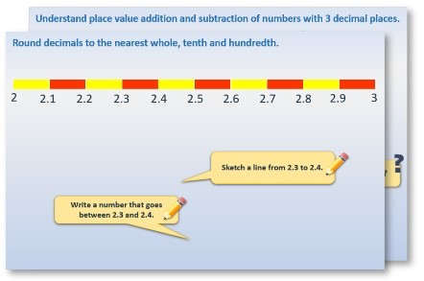
1.
Start by reading through the
Learning Reminders
.
They come from our
PowerPoint
slides.
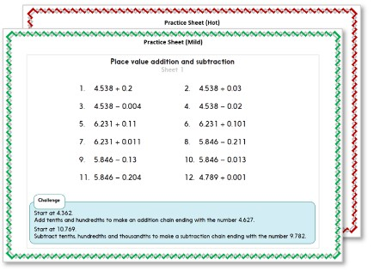
2. Tackle the questions on the Practice Sheet. There might be a choice of either Mild (easier) or Hot (harder)!
Check the answers.

Learning Reminders
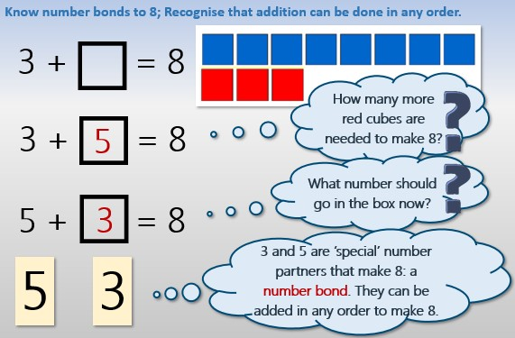
ã Hamilton Trust

Learning Reminders
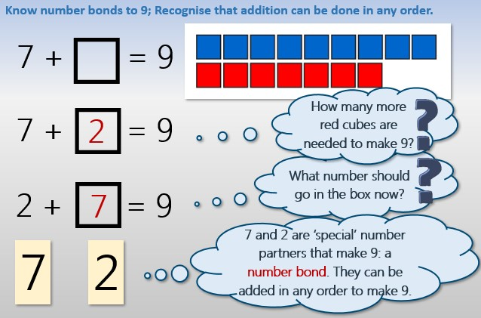
ã Hamilton Trust

